St Michael’s CE Academy
Newsletter

Friday 15th February 2019
Who’s Foot is this?

Dear Parent/Carer,
It’s been a while since we presented a newsletter. There is a good accumulation of events to report on and I hope you enjoy reading them and looking at the photos.
The term got off to a great start with the introduction of two new initiatives in our school. Every morning we give out bagels to our children. Hot toasted and buttered bagels which seem to be very popular. The children don’t feel quite so hungry by playtime these days!
We have also started our French lessons in KS2. Bonjour tout le monde! The children are really getting engaged with these lessons. You may hear children singing French songs, please encourage them. We also started den building at lunchtimes which adds another activity for the children to engage in.
Our KS1 children have recently done a showcase of their dancing skills. It was absolutely brilliant to see children as young as 5 years old emulating the movements of professional dancers. They were electrifying in their dance performance. Congratulations to them and their dance teachers: Miss Foster and Miss Revell.
We have recently had one of our TASC Days. TASC stands for Thinking Skills in a Social Context. Children work in small groups of mixed ages all through the day. They are given a problem that they have to solve together. This year they had to provide some entertainment for a Chinese New Year party. The performances were brilliant and judged by some of our Chinese parents.
Please can I let you all know in advance about Parents Evenings next half term. These will take place on the Monday 25th and Wednesday 27th of March 2019. They will be held in the usual style and letters will go out to you early next half term. Please ensure that you book an appointment with your child’s teacher so you can find out how they are doing.

Magic Breakfast

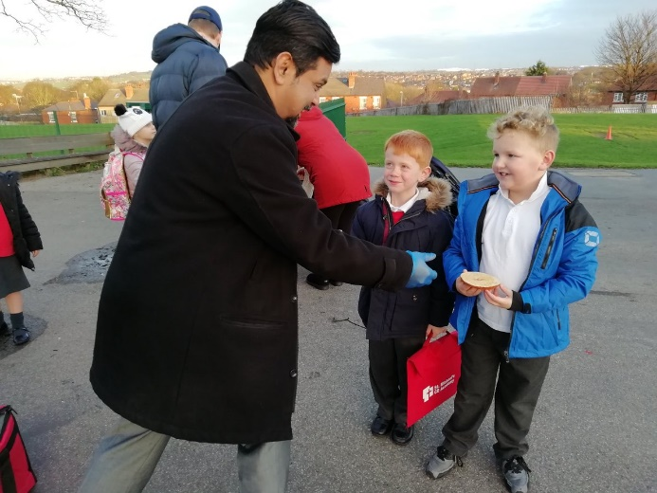

Year 1 – Pontefract Castle
Year 1 looked around the castle ruins as part of their castles and knights topic. They also took part in a workshop where they listened to a story about a boy who lived in a medieval castle. They got to look at different objects from the castle and they each made their own crown.
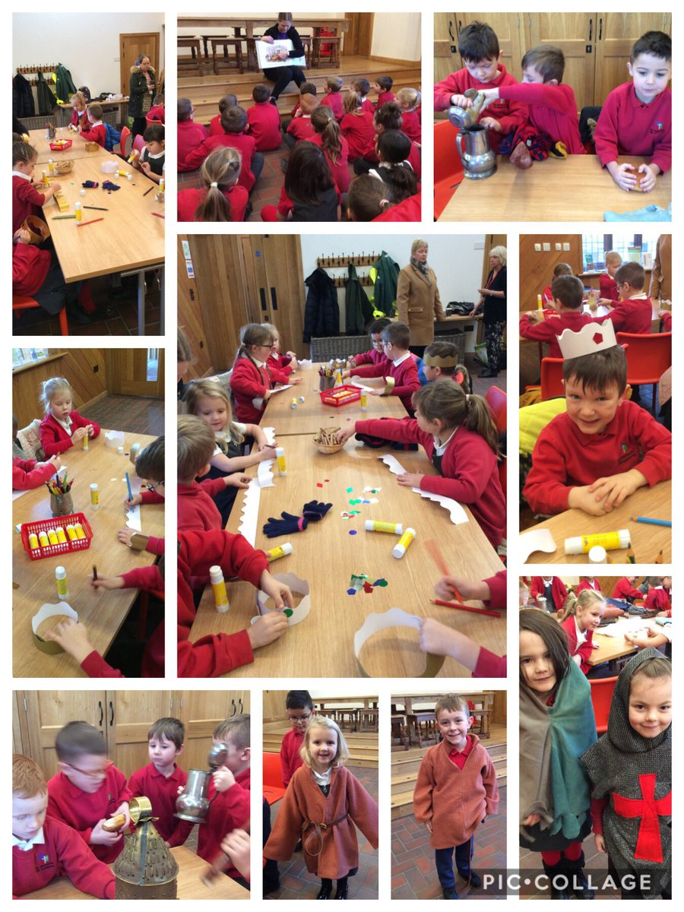
Year 6 Wakefield Museum
Our year 6 children enjoyed their workshop on the Mayans at Wakefield Museum. 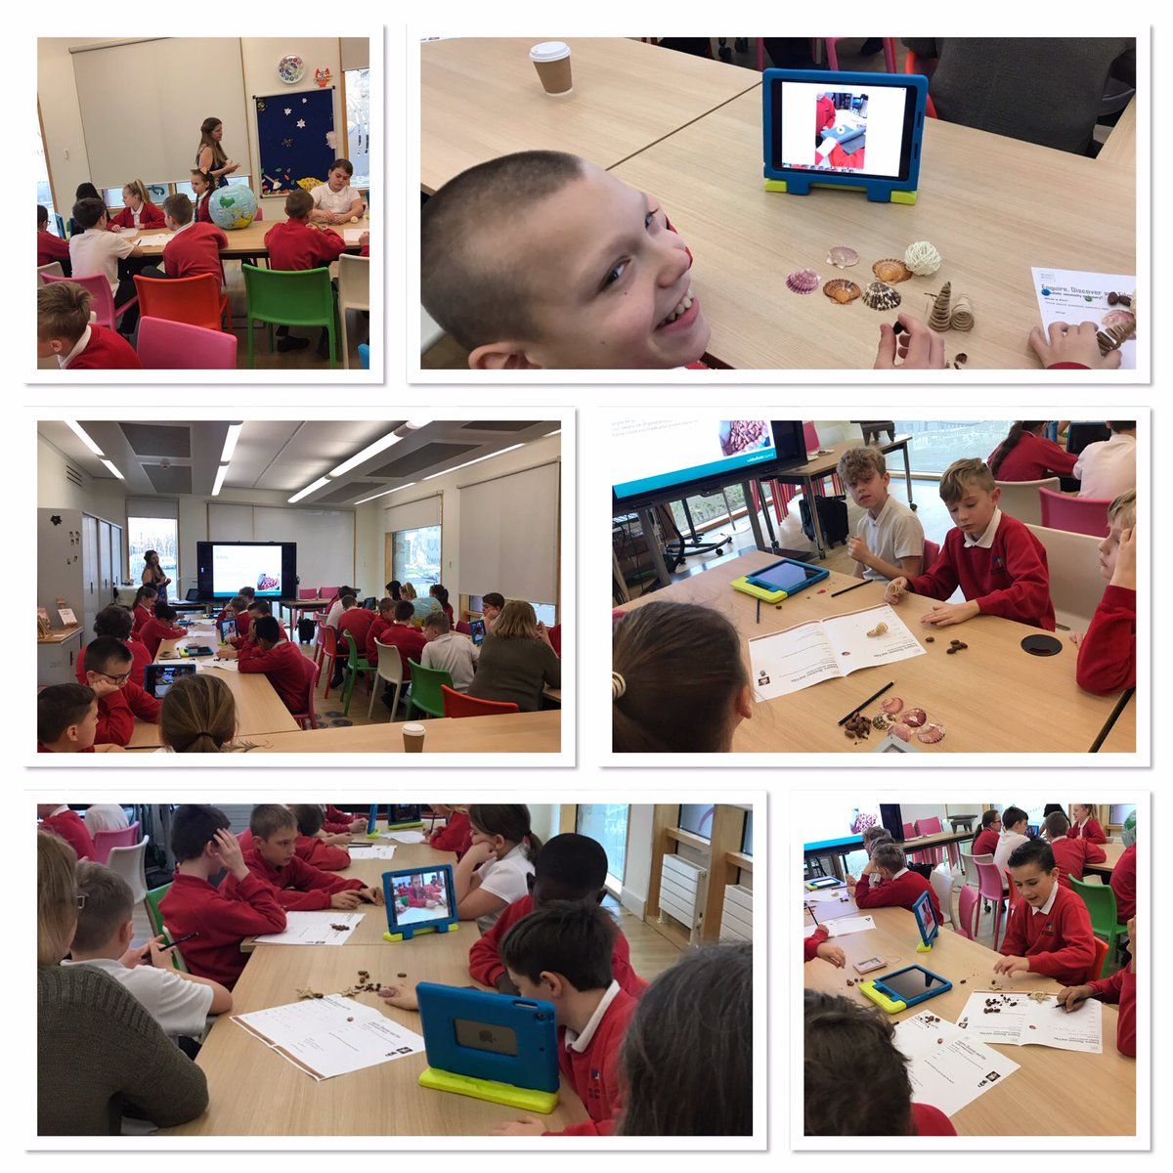

Sports
Netball
The year 5/6 netball team took part on the Cathedral Cluster competition. The children made great progress with their skills, teamwork and positioning as the competition went on and finished in a respectable joint 5th place. Well done to all the children involved.

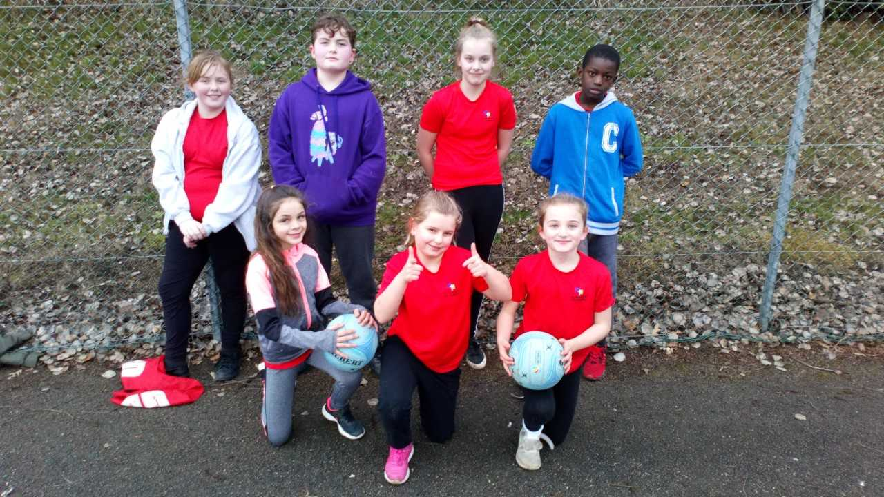

Sportability
This week, the St Michael's Sportability team took part in the Cathedral Cluster competition. They competed in a range of activities, including Boccia, Seated Volleyball and New Age Curling. They all had a fantastic time and finished in joint 5th place. Well done to all of the children.

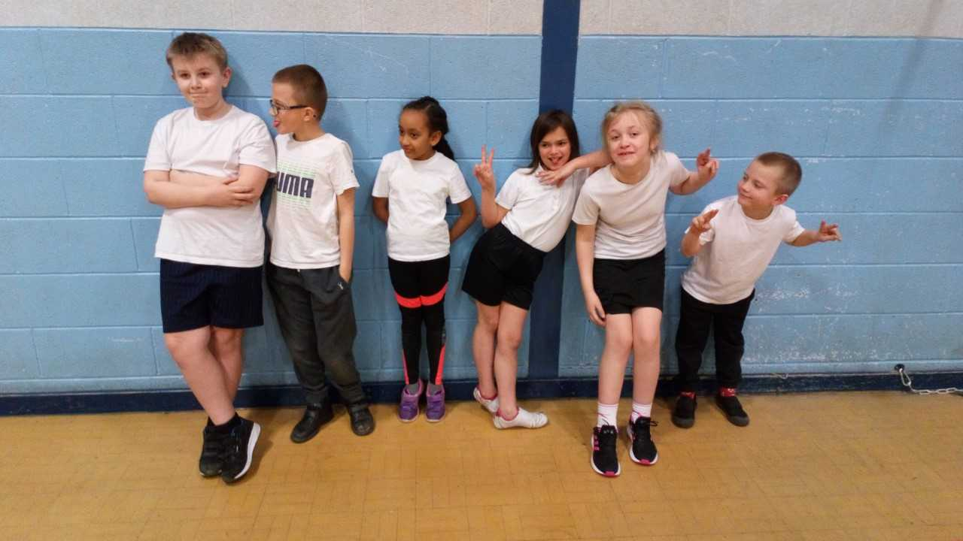

Athletics
This half term, our champion athletics team took part in the Wakefield final at St Thomas A Becket. They competed against four other schools, all performing various jumping, throwing and relay events. The children were all fantastic and never gave up in any race, even if their shoelace came untied! They came in 4th/5th place, which, out of the 74 primary schools in the Wakefield area, is an amazing achievement. Well done to all the children.
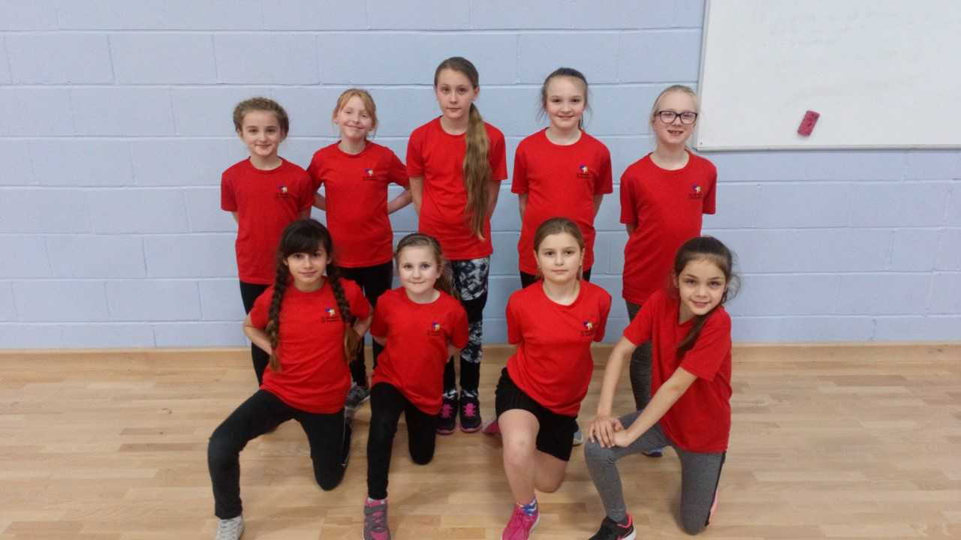

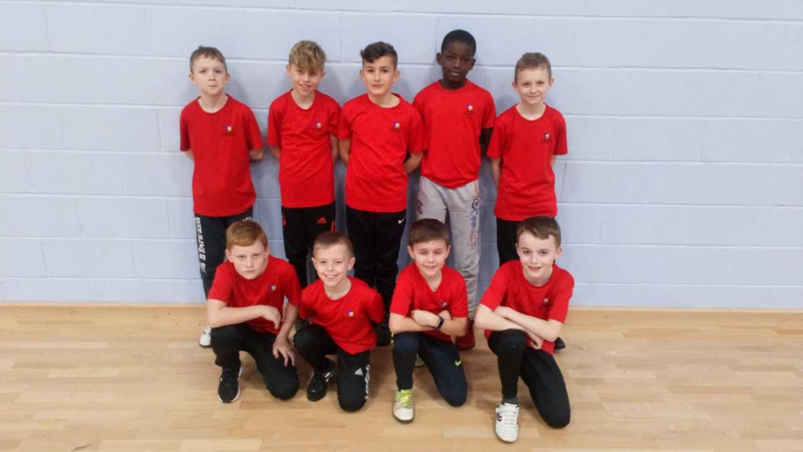
Cross Country
This half term, the children who had qualified from the first round of the Cross Country took part in the Wakefield final at Crigglestone All Blacks Rugby Club. There were at least 40 children running in each race and with only those finishing in the top 10 qualifying for the West Yorkshire finals, there was tough competition. All the children ran with great heart and determination; none of them gave up, despite it being a much longer course than they had completed in the previous round. Four of our children have qualified for the West Yorkshire finals in their respective year group race: Mia Spedding (4th), Josh Bramham (7th), Alisha Silveria (9th) and Kassey Dibbassey (5th). A fantastic achievement by those four, and also well done to all the other children who took part.

Reminders

Year 6 - Robinwood payment 1 - due on the 28th February.
Please pay this via Parentpay or request a barcoded letter from the school office to pay at a Paypoint shop. Thank you
Year 5 – Cathedral Academy
Year 5 children have been invited to spend the day at Cathedral Academy for a day of activities.
Your child has been sent home with a letter which you must complete and return to school for your child to beable to attend.
World Book Day – Friday 8th March
All children are invited to come to school dressed as their favourite book character.

After school clubs

If your child has been in one of the clubs listed in red this term they can continue this club after the February holidays. If they no longer require a place please let us know so that we can offer the place to another child. Letters have been sent out to confirm places for the new clubs which are marked in black.

MONDAY | BISCUIT/CAKE DECORATING
WEDNESDAY | UKULELE
WEDNESDAY | FUNKY FITNESS
WEDNESDAY | IPAD
WEDNESDAY | FILM
WEDNESDAY | GYMNASTICS
WEDNESDAY | COMPUTING
WEDNESDAY | IPAD
WEDNESDAY | GARDENING
WEDNESDAY | ARTS AND CRAFTS
THURSDAY | LEGO
THURSDAY | TEAM GAMES
MONDAY | DODGEBALL
TUESDAY | CRICKET
WEDNESDAY | GIRLS SPORTS
THURSDAY | HOCKEY

