Year 2 Autumn 1 History: London’s Burning
What I should already know:
- London is our capital city and King Charles III is our king.
- Florence Nightingale and Mary Seacole are significant women from the past and the Battle of Wakefield is a significant event.
- We remember people and events that are significant because they affected a lot of people over a long period of time, or they changed the way we do things for the better.
- Technological changes have made life better in homes, schools and cities.

Key vocabulary |  | 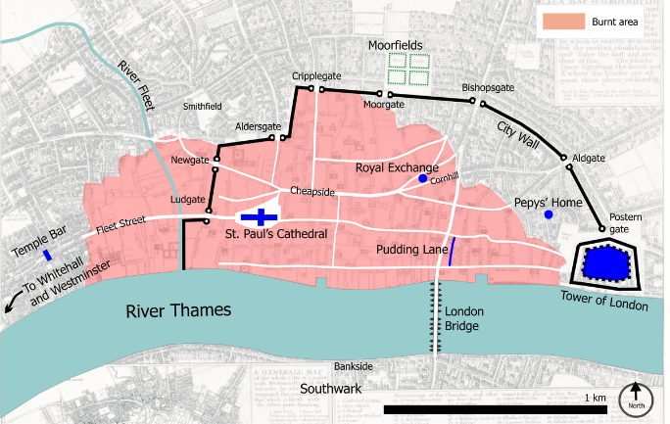  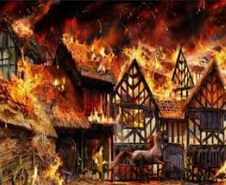 | What I will know (sticky knowledge):
Bakery | A shop where bread and cakes are made. |  | - I know that the fire started in Thomas Farriner’s bakery on Pudding Lane in 1666.  - I know that houses in London were built close together out of wood and straw, and this helped the fire spread quickly.  - I know Samuel Pepys wrote a diary about what happened.  - I know that the fire burned for five days.  - I know that London has changed since this event as they now have fire brigades and houses are mainly made of brick and concrete.  - I know that changes (technological advancements) have improved our cities since the 17th century.
St Paul’s Cathedral | A very large church in London.
Diary | A book in which people write about their lives.
Samuel Pepys | A friend of King Charles II who wrote diaries about the fire.
Fire break | When buildings are destroyed to stop the fire spreading.
King Charles II | The King of England in 1666.
Thatched roof | A roof built from straw.
River Thames | Main waterway in England which runs through London.

