Year 5 Autumn 2 History: What can archaeology teach us about Anglo-Saxon Britain?
What I should already know:
- I know that the Romans invaded and settled in Britain and Britain was part of the Roman Empire until AD 410.
- I know that artefacts and sources found today can help us to learn about the past.
- I know that the Ancient Egyptian civilisation was ruled by Pharaohs and the Ancient Greeks had a democracy.
- I know that under Roman rule, Britain had converted to Christianity.
Key vocabulary |  | 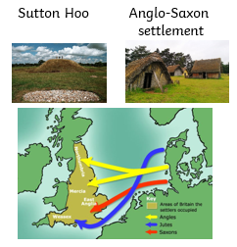  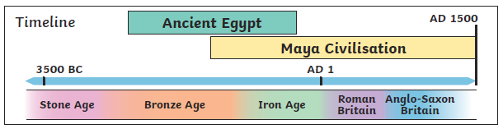 | What I will know (sticky knowledge):
Kingdom | An area ruled by a king or queen. |  | - The Anglo- Saxons came from Germany and Denmark in AD 410 after the Romans had left Britain.  - The ‘Dark Ages’ was the period after the Roman Empire when archaeologists thought Britain went into a decline.  - The discovery of the Staffordshire Hoard and Sutton Hoo changed the view that Britain was in the Dark Ages.  - Sutton Hoo was a mound of earth excavated in 1939 revealing the burial ship of an important Anglo-Saxon.  - The Staffordshire Hoard was discovered by Terry Herbert with a metal detector in 2009.  - I know that Saxons were initially Pagans and believed in many gods but became Christians, building churches and settling up monasteries.  - I know that the Anglo-Saxon period ended when the Normans conquered in 1066.
Pagan | Someone who believes in many gods.
Excavate | To remove earth that is covering objects buried in the ground to discover things about the past.
Settle | To arrive in a new place and start to live there and use the land.
Invade | Enter a place by force.
Warrior | A brave or experienced soldier or fighter
Sutton Hoo | Site of a ship burial of an important Anglo-Saxon.
Staffordshire Hoard | Largest collection of Anglo-Saxon treasure found in 2009.

