Writing Intent, Implementation & Impact – St Michael’s CE Academy
Intent
At St Michael’s CE Academy, our bespoke writing curriculum is designed so all children can become skilful, independent and enthusiastic writers. Our curriculum aims to give true meaning and purpose to writing, carefully connecting this idea to the fact that children enjoy writing to ‘real’ purposes and audiences in particular. Across a wide range of meaningful and carefully planned forms, with step-by-step teaching underpinned by quality modelling and quality core texts, our children write with increasing clarity, fluency ad richness. Our texts, models and experiences expose our writers to a wealth of enriched vocabulary that is then in turn independently applied to quality outcomes. Through our clear and progressive teaching cycles children are provided with the knowledge, skills and vocabulary to help them craft consistently excellent writing.

The five key intentions of our ‘3Cs’ Writing approach are to:
- Provide a clear and cyclical sequence of teaching writing that enriches, engages and meaningfully connects together both prior reading and writing learning
- Develop and foster a genuine love for writing that is then proudly reflected in ‘published’ outcomes
- Provide real, focussed and exciting writing opportunities across a wide range of forms
- Expose children to enriched, Tier 2 and Tier 3 vocabulary that can then be applied not only in writing but also across the children’s own language and lives
- To improve the children’s independent spelling skills

Implementation
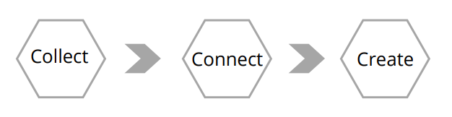

Each of our writing teaching cycles follows the structure of Collect > Connect > Create

Within the ‘Collect’ stage, children explore and learn the skills of writing through 'writing as a reader'.
Children engage with high quality models/WAGOLL's (What A Good One Looks Like), setting the expectation of the final outcome and allowing children to identify key features of different genres. Children collect and generate high quality tier 2 and 3 vocabulary, as they 'magpie' expert words and phrases used in quality texts. exploring the purpose behind why they have been used for an intended audience and purpose.

In the ‘Connect’ stage of our learning, teachers explicitly model and support the composition of writing, manipulating the collected content into sentences using grammar skills from the national curriculum. Through guided and shared practice, children construct relevant, focussed sentences and develop their writing skills, continuously improving their work through our editing sessions.

Finally, children ‘Create’ their final published piece, after drafting sections or paragraphs of text using the writing skills taught within the connect phase. Children 'write as readers' by editing and improving their drafts before publishing a final piece for their intended purpose and audience.

Handwriting is explicitly and sequentially taught/modelled within writing sessions as per the Read Write Inc curriculum, drawing on and building on embedded mnemonics, routines and strategies.

The teaching of the statutory spelling rules is implemented through a range of strategies. From direct phonic teaching in EYFS/KS1, to direct teaching Read Write Inc-supported spelling approaches in KS2 our children are provided with a range of successful spelling strategies and therefore have the ability to apply them in their independent work. This spelling teaching is also detailed on our writing long term plans.

Impact
The impact of our writing approach is that children are increasingly confident, independent and enthusiastic writers who recognise how writing can impact on people’s lives. With quality models and texts to inspire them and rich, focussed vocabulary supporting their journey they become wide-reading and wide-ranging writers over time. Our writing is rigorously assessed, monitored and moderated against our agreed assessment documentation at both a school and trust level.

