Little Learners and Nursery phonics progression

Children in Little Learners and Nursery must develop their pre-phonics abilities to enable them to start RWI naming pictures and phonemes in Spring 2 of Nursery.
Children you acquire these early abilities and confidence will become more assured and confident readers. Through stories, songs and games from Super Sounds, Little Learners are given the opportunity to learn how to recognise, tune into and recall noises that they can talk about. The activities will enhance sound discrimination in the environment, such as sound walks. They will investigate body and instrument percussion sounds to further their listening and attention skills. This will continue to be embedded through practice in Nursery, their phonological awareness is further developed through rhyme and alliteration voice sounds and onset and rhyme. This includes RWI Nursery programme where children are introduced to high quality stories that make them excited about books and story time. - Begin to hear oral ‘Fred Talk’ (segmenting) and begin to make links between single sounds and the words they build. - Begin to learn the pictures associated with the speed sounds. - Once children are beginning to orally blend and recognise the pictures, children begin to learn the graphemes for set 1 single letter sounds before entering Reception

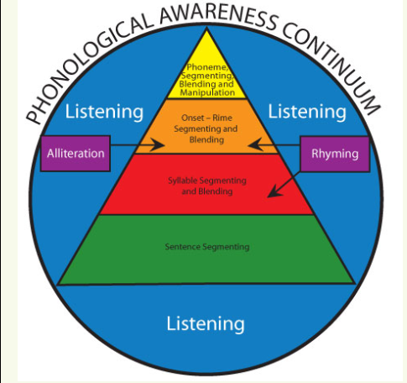

Phonological awareness: Is the overall umbrella referring to the awareness of the sound structure of a spoken word (Gillon, 2004).


Nursery RWI LTP Overview – 2023/24
 | Autumn 1 | Autumn 2 | Spring 1 | Spring 2 | Summer 1 | Summer 2
Developing phonological awareness | Every day sounds  Musical sounds  Warming up our voices and bodies  2 planned sessions per week for each strand | Every day sounds  Musical sounds  Warming up our voices and bodies  2 planned sessions per week for each strand | N1 new starters begin Autumn 1  (N2)  Wriggle to the Rhythm  Shinning at Rhyming  2 planned sessions per week for each strand  Embed through provision Every day sounds  Musical sounds  Warming up our voices and bodies | Easy Peasy Alliteration  Wriggle to the Rhythm  Shinning at Rhyming  2 planned sessions per week for each strand  Embed through provision Every day sounds  Musical sounds  Warming up our voices and bodies | N2 new starters begin Autumn 1  Easy Peasy Alliteration  Awesome blending and segmenting  2 planned sessions per week for each strand  Embed through provision Every day sounds  Musical sounds  Warming up our voices and bodies  Wriggle to the Rhythem  Shining at Rhyming | Revise and consolidate every strand  Embed every strand through continuous provision
RWI - On going throughout the year - Planned Talk Role play and growing vocabulary through play. Building Sentences and making up stories. (On weekly Planning)
Read Writ Inc |  |  | RWI  Fred games (modelling blending and segmenting) Daily | RWI  N2 Children going to Reception in September 2024 teach RWI Pictures and daily Fred games (modelling blending and segmenting)  Daily | RWI  N2 Children going to Reception in September 2024 teach RWI set 1  Teach Word Time if children can orally blend and segment  Daily | RWI  N2 Children going to Reception in September 2024 continue to teach RWI set 1 and word time  Teach Word Time if children can orally blend and segment  Daily

